EUROSTAR PASSHOLDER FARE BOOKING PROCESS
Book using the Belgian Railways website using this link:
https://www.b-europe.com/EN/Booking/Pass#TravelWish
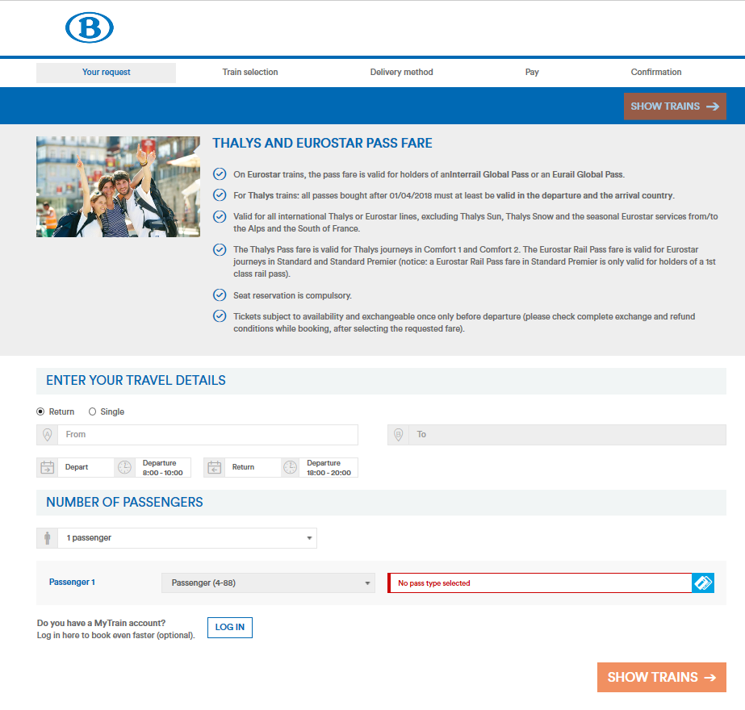

Fill in your journey details and choose either InterRail or EurRail – note that there are no discounts for children as all passengers are:

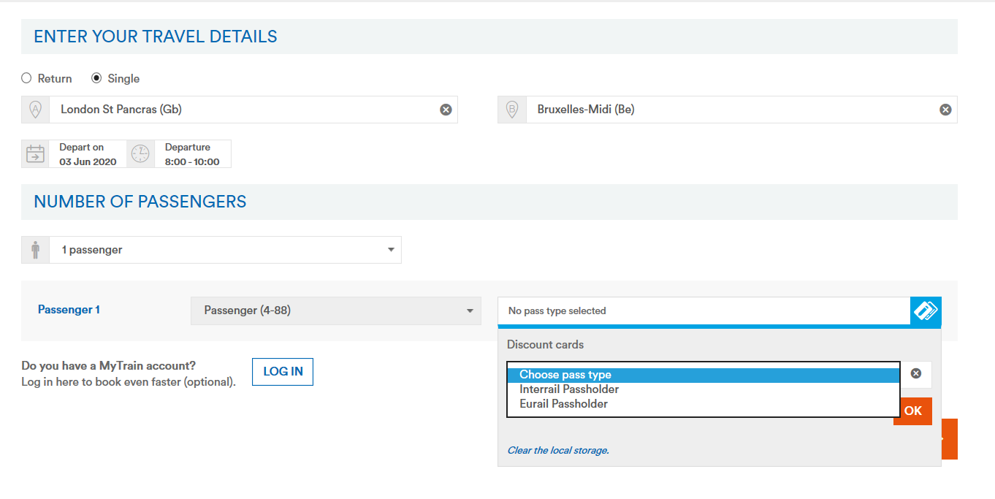

Select the train and class of travel:
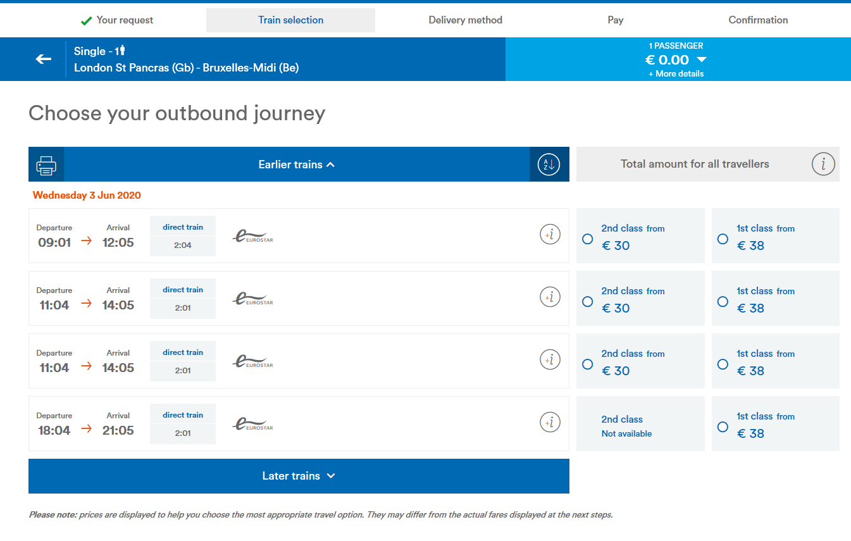

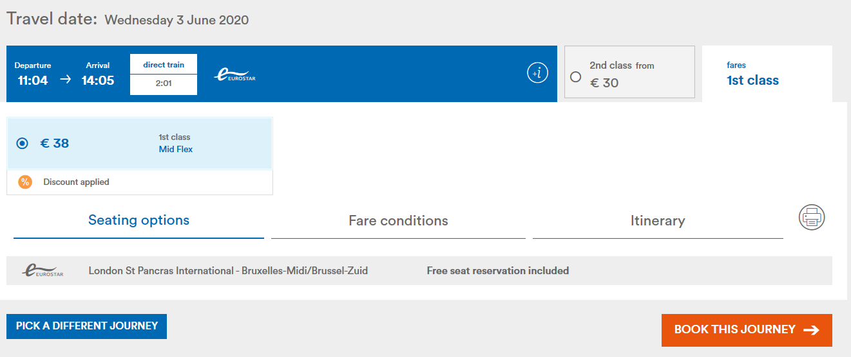

NOTE – there is a booking fee of €4 hidden as an e-ticket fee!
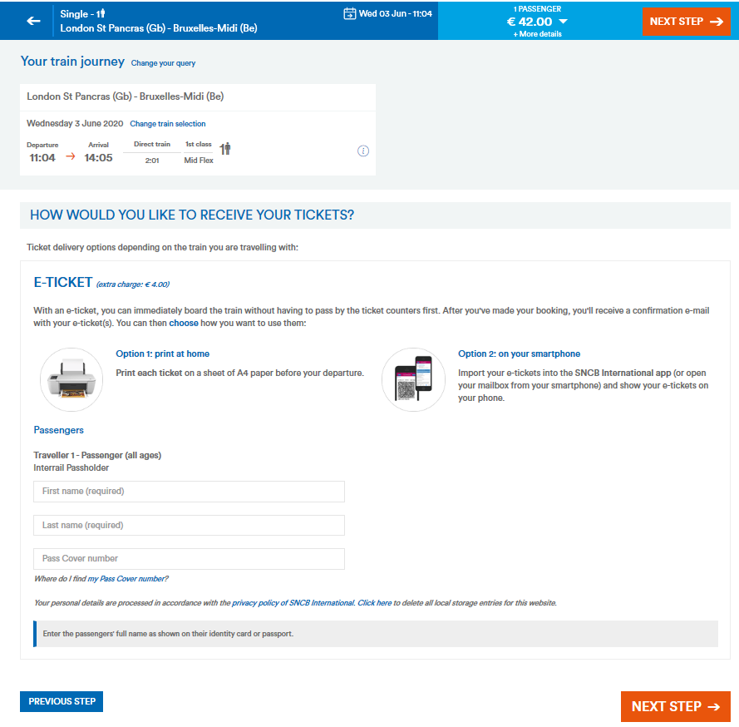

Note you will need to enter the InterRail Pass Cover Number:
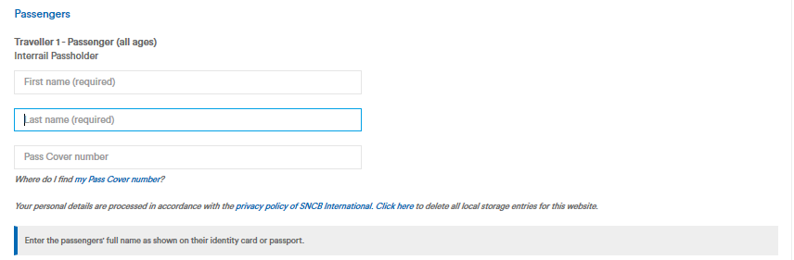

Fill in your contact details and choose payment method – once payment is made make a note of the booking reference number just in case the conformation email doe not come through!
